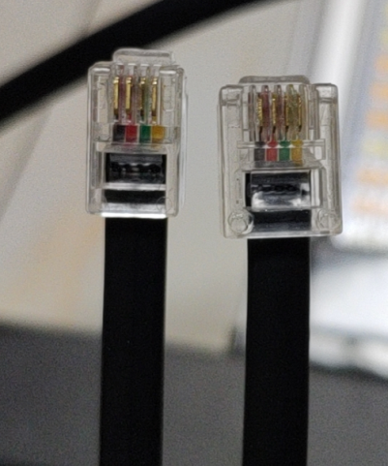
LED Driver 0-10VDIM
LED Controller
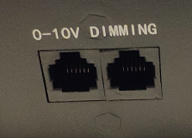

6P4C 6P4C

一：Individual control test：
- controller connected to the power supply.;
- take out the network cable, large head (6P4C) connected to the controller, large head (6P4C) connected to the power DIMMING (both ports can be connected);
- Touch the LED item of the controller face screen, slide to the right to unlock, enter 0-100 in the keyboard, press OK, you can control the output status.。
- Control steps: on-off - 50% - 100%
- Test completed, power knob adjusted to 100%, unplug the network cable, put away the controller.。

二：Multi-way parallel vehicle control:
LED Driver 0-10VDIM
LED Driver 0-10VDIM
LED Driver 0-10VDIM
LED Controller

RJ11network cable 6p4c RJ11network cable 6p4c

